MACH4METAL

metalworking machinery
Transito 21
6909 DA BABBERICH Netherlands
Tel. +31 (0)316-247123
Fax: +31 (0)316-247956
info@mach4metal.com
www.mach4metal.com

Bank No : 66.52.13.883
IBAN : NL33 INGB 0665 2138 83
BIC : INGBNL2A

FIM NOTCHING VERSA 206

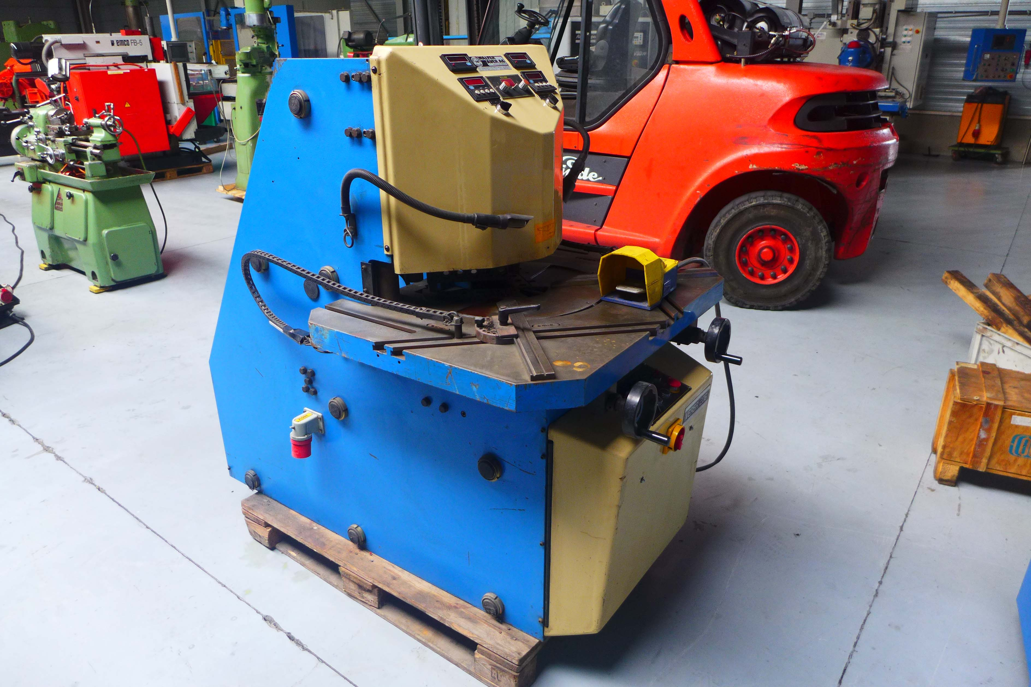
- Make : FIM Walter AUER AG
- Type : Versa 206
- Mach.No. : 206 198
- Y.o.p : 1998

- Cutting length : 200 mm
- Cutting length : 200 mm
- Thickness : 6 mm
- Blade length : 205 mm
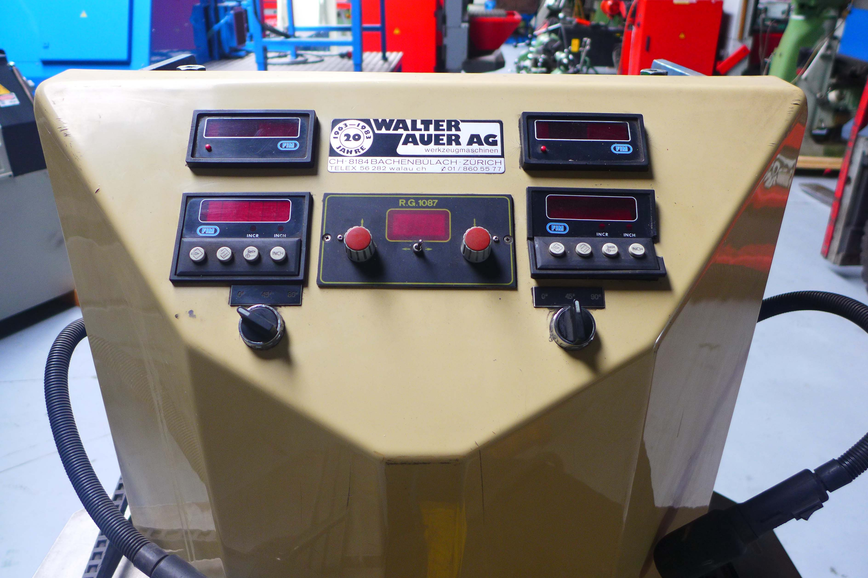
- Table length : 1000
- Table width v : 800
- Stroke’s p/min. : 60

- Min. cutting angle : 30°
- Max. cutting angle : 135°

- Angle cuts of 30° to 60° : 4 mm
- Angle cuts of 60° to 135° : 6 mm
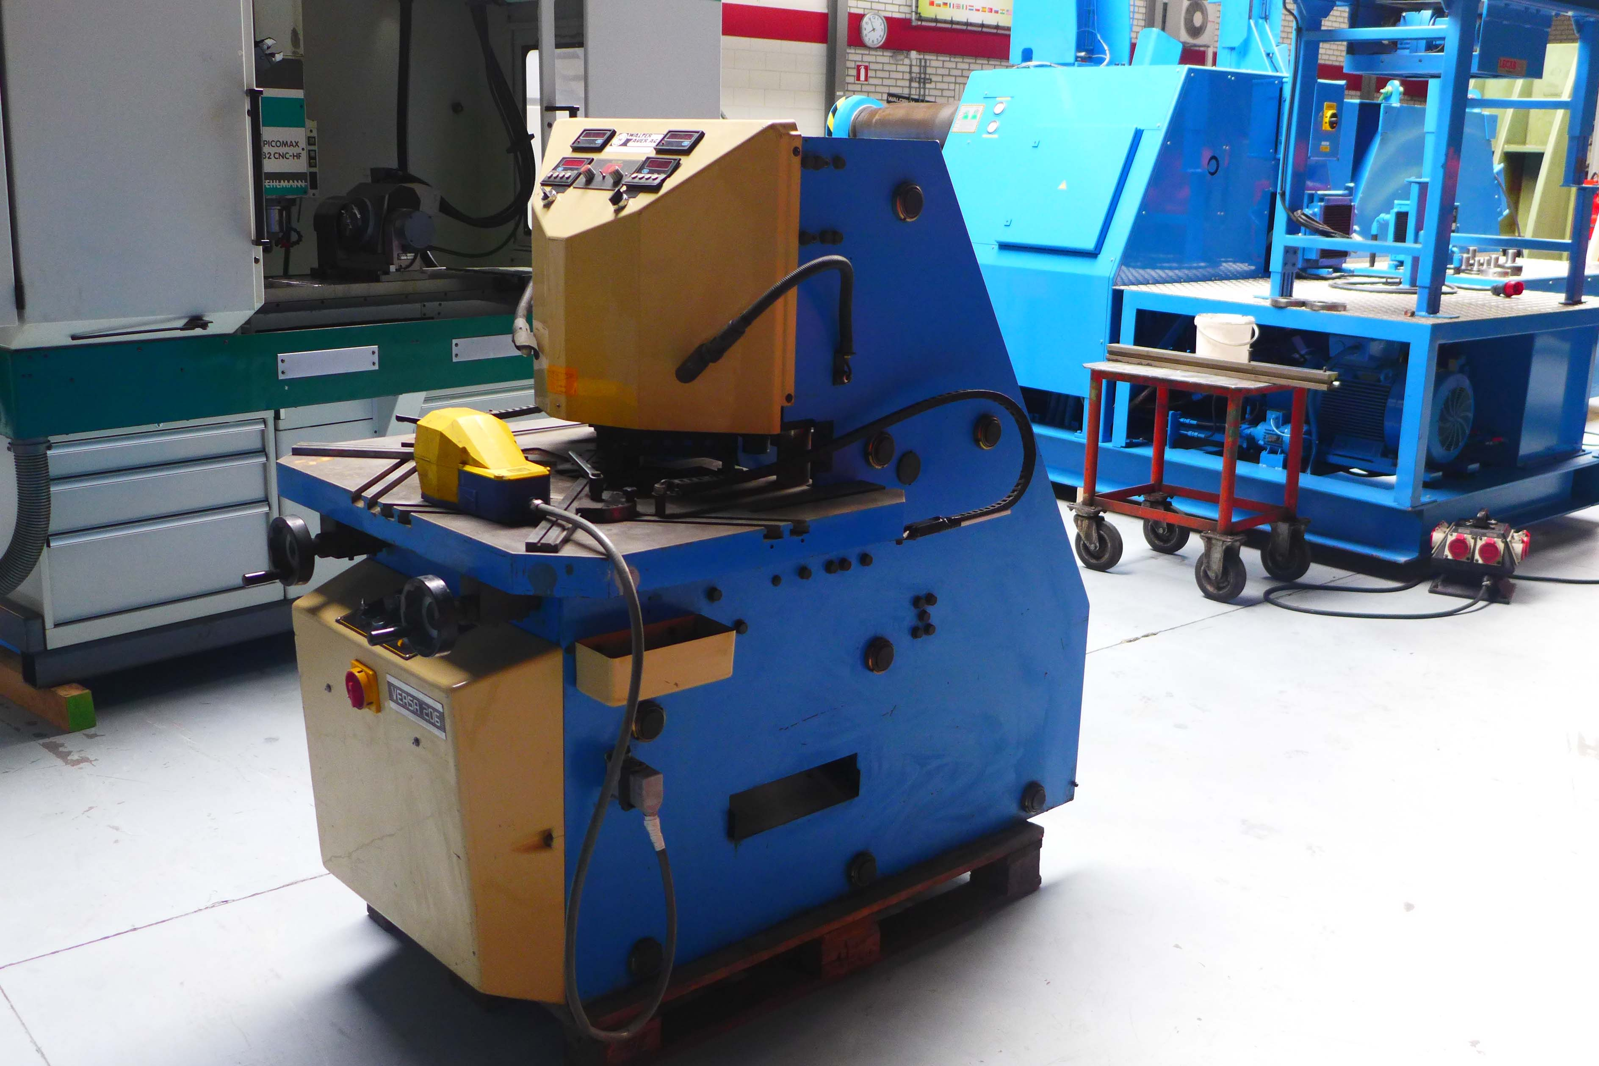
- Dimensions
- Length : 1.000
- Width : 1.600
- Height : 1.560
- Weight : 1.250 Kg

- Digital readout cutting depth
- Digital readout table stop
- Fully hydraulic machine

Please Note: The above information has been obtained to the best of our ability and belief from, and from the manufacturers where possible. It is given in good faith, but its accuracy can not be guaranteed. Accordingly, it will not form a representation or constitute contractual terms. We advise you to check any vital details

